The Ministry of Health of the Republic of Serbia
Nemanjina Street 22–26, 11000 Belgrade

SERBIA EMERGENCY COVID-19 RESPONSE PROJECT (P173892)
UPDATED STAKEHOLDER ENGAGEMENT PLAN

February 2021

Contents
1. INTRODUCTION 3
1.1 Project Description and Context 3
1.2 Project Components 4
1.3 Purpose and justification for the Project level SEP 6
2. Regulations and Requirements for Stakeholder Engagement 7
2.1 National Requirements 7
2.2 World Bank Requirements 7
3. Stakeholder identification and analysis 9
3.1 Methodology 9
3.2 Stakeholder Definition and Identification 10
4. Stakeholder Engagement Program 14
4.1. Summary of previous stakeholder engagement 14
4.2. Summary of project stakeholder needs and methods, tools and techniques for stakeholder engagement 15
4.3. Proposed strategy for information disclosure 16
4.4. Stakeholder engagement plan 22
4.5 Proposed strategy to incorporate the views of vulnerable groups 23
5. Resources and Responsibilities for implementing stakeholder engagement activities 24
5.1. Resources 24
5.2. Management functions and responsibilities 24
6. Grievance Mechanism 25
6.1. Description of GRM 26
6.2 Receiving Grievances 26
6.3 World Bank Grievance Redress System 27
7.Monitoring and Reporting 27
7.1. Reporting back to stakeholder groups 27
7.2 Monitoring Indicators 28
8. Budget for Implementing Stakeholder Engagement Activities 28
REPORT ON PUBLIC CONSULTATIONS 37

INTRODUCTION

Project Description and Context
An outbreak of the coronavirus disease (COVID-19) caused by the 2019 novel coronavirus (SARS-CoV-2) has been spreading rapidly across the world since December 2019, following the diagnosis of the initial cases in Wuhan, Hubei Province, China. On March 11, 2020, the World Health Organization (WHO) declared a global pandemic as the coronavirus rapidly spreads across the world.

The World Bank through the Fast Track COVID - 19 Facility is supporting the Government of Serbia to respond to the outbreak, prevent, and reduce contagion and loss of life.

The first case of COVID-19 in Serbia was confirmed on March 6, 2020. Since then, Serbia has experienced significant increases of daily new cases in each of the three peaks (March–April 2020, July–August 2020 and November–December 2020) of epidemics during 2020, resulting in the highest number of 7,999 daily new cases on December 1, 2020. (The highest number of daily new cases in the first peak was 445 cases (recorded on April 16, 2020) and the highest number in the second peak was 467 cases (recorded on July 26, 2020)). The highest daily percentage of infected people out of those tested recorded during the first peak, on March 23, 2020, was 61,36% and the highest percentage in the third peak, recorded on December 7, 2020, was 41,77%.

By December 31, 2020, there were 337,923 confirmed cases of COVID-19 in Serbia, and a total of 3.211 deaths caused by coronavirus.

COVID-19 control and containment measures in the Republic of Serbia

As mentioned above, there have been three peaks to the COVID-19 outbreak in Serbia. All of them have significantly impacted the health, financial security, and the way of living and working of people in Serbia. The crisis is ongoing, and its development remains uncertain with the socio-economic impacts of COVID-19 being significant.

Before stringent NPI measures had been put in place, the Government had already initiated a national coordination strategy from the highest levels, and a public communication strategy. The social measures included:
- Closure of all pre-schools, primary schools, high schools and universities (March 15, 2020);
- Forced quarantine for all those above 65 years of age (March 15, 2020);
- Restriction of operations of intracity and intercity public transport, except for a few special lines (March 15, 2020);
- Mandatory 15 days or 28 days of self-quarantine for those entering Serbia depending on the country of travelling from (March 15, 2020)
- Introduction of a state of emergency and a curfew from 8pm to 5am (March 18, 2020) then from 5pm to 5am (March 22, 2020);
- Closure of the international airports (March 19, 2020) and closure of all national borders for passenger transport (March 20, 2020);
- Closure of restaurants, bars, public parks, gyms and shopping malls (March 21, 2020);

Testing capacities in Serbia were expanded by large both in Belgrade and other cities. This measure represented the essence of the containment strategy in Serbia throughout the first peak of the epidemics in March, April and May of 2020.

During the first peak, the authorities in Serbia established three temporary hospitals (in Belgrade, Niš and Novi Sad) where the persons with positive PCR test were admitted in order to be isolated from the community. The Belgrade temporary hospital, with 1,000 beds, located at the Belgrade Fair, was opened on the March 28, 2020 and closed towards the end of May 2020.
The second peak of the outbreak, with a slight increase in the number of daily cases, caused the reopening of a field hospital – this time at the Belgrade “Stark” Arena with a capacity of 500 hospital beds with oxygen supply, for patients with milder clinical symptoms.
In July 2020, GOS decided that special “COVID hospitals” should be built – one in Belgrade (Batajnica), with the capacity of 1,000 hospital beds, and one in Krusevac, with the capacity of 500 hospital beds. Those hospitals were opened in December 2020 and patient admission started immediately.

Two laboratories with daily capacity for PCR testing of 1,000 samples were opened: “The Fire Eye” in Belgrade in April 2020, and “The Fire Eye” in Nis in July 2020.
The key measures that are currently in place in Serbia are:
- Face masks are mandatory in all closed spaces;
- Public gatherings are forbidden;
- The indoors gatherings are limited; the number of people allowed depends on the type and location of a gathering;
- The recommended distance between people is 2 meters.

Between November 24 and December 3, 2020, in order to contain the spread of the virus, the GOS introduced temporary measures, including reduced working hours of restaurants, cafes, bars, clubs, supermarkets and shopping malls, bans on public gatherings involving more than five people (indoors or outdoors), and limits on the number of people present at all times in relation to the square footage of a facility (4 m² per person in offices, shopping malls etc).
As of November 30, 2020, classes for school children from the fifth to the eighth grade of primary schools and for university students have been realized online.

Economic measures that were implemented since November 2020, can be summarized as follows:
- Public-sector health workers received a one-off assistance of RSD 10,000 (EUR 85) at the end of 2020;
- Pensioners received additional RSD 5,000 (EUR 43);
- The GOS announced subsidies to support travel agencies and tourism companies. For these purposes, the government has approved RSD 150 million (EUR 1.3 million).

Another process that started in Serbia in December 2020, is the vaccination of the population. The GOS is committed to purchasing vaccines from different manufacturers in order to provide sufficient quantities. The first two batches of several thousand vaccines, one manufactured by Pfizer-BioNTech and one manufactured in Russian Federation (Sputnik V), were purchased in December 2020/January 2021. Following approval by the Medicines and Medical Devices Agency of Serbia (MMDAS), the regulatory body for pharmaceutical products approval for Serbia, vaccination of the priority population groups started in line with IPHS’ Immunization Plan. The third batch of 180.000 doses of vaccines manufactured in China (Sinofarm) was delivered in mid-January and was approved by MMDAS on January 16, 2021.

Project Components
The Serbia COVID-19 Response Project comprises the following components:

The project will have two (2) components: (1) Emergency COVID-19 Response (with 3 sub-components) and (2) Implementation Management, Monitoring and Evaluation.

Component 1: Emergency COVID-19 Response.
This component will provide immediate support to Serbia to enable limiting the local transmission of SARS-CoV-2 through containment strategies. The component will enable Serbia to mobilize surge response capacity through trained and well-equipped front-line health workers. Supported activities include:

Subcomponent 1.1: Case Detection, Confirmation, Contact Tracing, Recording, Reporting. This subcomponent will help (a) strengthen disease surveillance systems, national reference and public health laboratories, and epidemiological capacity for early detection and confirmation of cases; (b) combine the detection of new cases with active contact tracing; (c) support epidemiological investigation; (d) strengthen risk assessment; and (e) provide on-time data and information for guiding decision-making and response and mitigation activities. Additional support will be provided to strengthen Serbia’s health management information system (HMIS) to facilitate recording and on-time virtual sharing of information.
- Subcomponent 1.2: Physical Distancing Measures and Communication Preparedness. Sub-component 1.2 combines activities listed in Component 1 of the global MPA PAD under ‘Social Distancing Measures’ and ‘Communication Preparedness’.

  - Physical distancing measures. An effective measure to prevent contracting a respiratory virus, such as SARS-CoV-2, is to limit contacts with other people—"physical distancing.” Financing will be made available for Serbia to develop guidelines on social distancing measures (e.g., in phases) to operationalize existing or new laws and regulations, support coordination among sectoral ministries and agencies, and support the MoH in protecting health workers and other personnel involved in pandemic control activities. Additional preventive actions will be supported that will complement physical distancing—for example, personal hygiene promotion, including promoting handwashing; distribution and use of masks; and promotion of increased awareness and community participation in slowing the spread of the pandemic. Specific interventions for vulnerable communities—including Roma populations, residents of women’s shelters, and prisoners— will be supported as needed. Specifically, the project will build on what has been done so far, and on the lessons that are emerging about the efficacy of NPIs in the Serbian context.
  - Communication preparedness. Activities will include developing and testing messages and materials to be used in a pandemic or emerging infectious disease outbreak, and enhancing communication infrastructure to disseminate information from the national to the regional and local levels and between the public and private sectors. Communication activities will support cost-effective and sustainable methods such as promotion of handwashing through various communication channels (mass media, counseling, schools, workplaces), and by integrating them into specific interventions and into the ongoing outreach activities of ministries and sectors, especially the ministries of health, education, environment, agriculture, and transport. Support will be provided for information and communication activities to increase the attention and commitment of GoS and the private sector and civil society; to raise awareness, knowledge, and understanding among the general population about the risk and potential impact of the pandemic; and to develop multi-sectoral strategies to address the pandemic. In addition, support will be provided for (a) the development and distribution of basic communication materials for the general public, such as question-and-answer sheets and fact sheets in appropriate languages on COVID-19 and general preventive measures; (b) information and guidelines for health care providers; (c) training modules (web-based, printed, and video); (d) presentations, slide sets, videos, and documentaries; and (e) symposia on surveillance, treatment, and prophylaxis.

Subcomponent 1.3: Health System Strengthening. Assistance will be provided to the health care system for preparedness planning to provide optimal medical care, maintain essential community services, and minimize risks for patients and health personnel, including training health facilities staff and front-line workers on risk mitigation measures. Strengthened clinical care capacity will be achieved through financing the establishment and refurbishment of specialized units in selected hospitals, preparation of treatment guidelines, and conduct of clinical training of health workers. Strategies will also be developed to increase hospital bed availability, including deferring elective procedures, stringent triage of patients in all health facilities and before admission, and earlier discharge with follow-up by home health care personnel. Specifically, the project will procure (a) ambulances and other vehicles, as well as vehicles for epidemiological departments of the institutes of public health; (b) hospital beds and vital signs monitors; (c) X-ray machines for hospitals and primary health care institutions; (d) computed tomography (CT) scanners; e) ultrasound devices; f) any other type of medical equipment as estimated necessary by MoH and approved by the Bank.

Component 2: Implementation Management and Monitoring and Evaluation. For project management, the existing PCU of the MoH for the ongoing SSHP will be responsible for coordinating project activities and carrying out the fiduciary tasks of procurement and financial management (FM). As required, the PCU will be strengthened through the recruitment of additional staff and consultants. The project will cover the costs associated with project management and coordination. The subcomponent will also support the Monitoring & Evaluation (M&E) of prevention and preparedness, building capacity for clinical and public health research and joint learning across and within countries. It will also support training in participatory M&E at all administrative levels, evaluation workshops (considering social distancing measures, or virtual evaluation), and development of an action plan for M&E and replication of successful models.

Purpose and justification for the Project level SEP
Operations and activities for which the World Bank`s Investment Project Financing (IPF) is sought after October 1, 2018 fall under the application of the Environmental and Social Framework (ESF). The ESF comprise, inter alia, the 10 Environmental and Social Standards which set out mandatory requirements for the Borrower and the Project. Under the ESS10, a Stakeholder Engagement Plan (SEP) should be developed prior to Project appraisal that sets out the principles and procedures for stakeholder engagement in a manner that is consistent with ESS10.
The Serbia COVID-19 Response Project is being prepared under the World Bank’s Environment and Social Framework (ESF). As per the Environmental and Social Standard ESS 10 Stakeholders Engagement and Information Disclosure, the implementing agencies should provide stakeholders with timely, relevant, understandable and accessible information, and consult with them in a culturally appropriate manner, which is free of manipulation, interference, coercion, discrimination and intimidation.

The overall objective of this Stakeholder Engagement Plan (SEP) is to define a program for stakeholder engagement, including public information disclosure and consultation, throughout the entire project cycle. The SEP outlines the ways in which the project team will communicate with stakeholders and includes a mechanism by which people can raise concerns, provide feedback, or make complaints about project and any activities related to the project. The involvement of the local population is essential to the success of the project in order to ensure smooth collaboration between project staff and local communities and to minimize and mitigate environmental and social risks related to the proposed project activities. In the context of infectious diseases, broad, culturally appropriate and adapted awareness raising activities are particularly important to properly sensitize the communities to the risks related to infectious diseases.

It should be noted that the current SEP has been developed in a broad manner to allow stakeholder engagement covering the entire project. The deployment of any of the envisaged measures will depend on the project activities that will actually be implemented.

Regulations and Requirements for Stakeholder Engagement

2.1 National Requirements
The commitments and requirements of the Republic of Serbia to citizen engagement are not residing under a single self-standing law or regulation. However, the recognition of importance of citizen engagement is infused in the legal system and clearly recognized by mandatory procedures provided under individual laws. Serbia having acquired the EU candidate country for membership status, is taking a huge effort to reach environmental standards in line with the EU acquis which extends to issues of stakeholder and citizen engagement as well.
From the highest legal act down to an ample normative framework comprising the Serbian legal system, a strong commitment and openness to stakeholder engagement is evident. Key laws governing the stakeholder and citizen engagement activities include, but are not limited to:
The Constitution of the Republic of Serbia (2006) proclaims the rule of law and social justice, principles of civil democracy, human and minority rights and freedoms, and commitment to European principles and values. The Article 74 proclaims the right to healthy environment and grants the right to timely and comprehensive information on the state of the environment.
The Law on free access to information of public interest (2004) states that governmental agencies, social associations and officials are required to provide each person with the possibility of receiving and becoming acquainted with documents of public interest, except in cases anticipated by law. By virtue of this Law access to information shall be granted to all stakeholders, including every natural person or legal entity upon written request unless otherwise regulated by the Law. Within 15 days of receipt of a request at the latest, the authority shall inform the applicant whether the requested information is held, and grant him/her access to the document containing the requested information or issue or send to the applicant a copy of the document, as the case may be.
Law on Public Information and Media (2014) stipulates that public information is free and is not subject to censorship, that the public has the right and the interest to be informed on issues of public interest, that monopoly in the media is not allowed, that information on the media is public.
The Law on Environmental Impact Assessment (2004 as amended in 2009) provides categorization of industries and projects and identifies types of environmental assessment required against respective categories of industries or projects and provides procedures for disclosure, presentation and consultation requirements, and sets these as mandatory with a disclosure minimum of 20 days.
The Republic of Serbia ratified the Aarhus Convention on Access to information, public participation in decision-making and access to justice in environmental matters and it links environmental and human rights and resides on the belief that it is a basic right of present and future generations to live in an environment adequate to health and wellbeing. The convention focuses on achieving this through the implementation of three pillars: rights of access to information, access to decision-making, and access to justice.
Other stakeholder engagement, disclosure and transparency requirements within certain topics and sectors are embedded in the applicable laws regulating each of the treated subject. They are broadly compliant to the requirements of ESS10 but have certain shortcomings when it comes to active outreach and continuous engagement strategies.

2.2 World Bank Requirements
ESS10 objectives are the following:
- To establish a systematic approach to stakeholder engagement that will help Borrowers identify stakeholders and build and maintain a constructive relationship with them
- To assess the level of stakeholder interest and support for the project and to enable stakeholders’ views to be taken into account in project design and environmental and social performance
- To promote and provide means for effective and inclusive engagement with project-affected parties throughout the project life cycle on issues that could potentially affect them
- To ensure that appropriate project information on environmental and social risks and impacts is disclosed to stakeholders in a timely, understandable, accessible and appropriate manner and format.
- To provide project-affected parties with accessible and inclusive means to raise issues and grievances allow Borrowers to respond to and manage such grievances.
A Stakeholder Engagement Plan (SEP) proportionate to the nature and scale of the project and its potential risks and impacts needs to be developed by the Borrower. It has to be disclosed as early as possible, and before project appraisal, and the Borrower needs to seek the views of stakeholders on the SEP, including on the identification of stakeholders and the proposals for future engagement. If significant changes are made to the SEP, the Borrower has to disclose the updated SEP. The Borrower should also propose and implement a grievance mechanism to receive and facilitate the resolution of concerns and grievances of project-affected parties related to the environmental and social performance of the project in a timely manner.

The WB particularly emphasizes effective, inclusive and genuine citizen engagement through disclosure of project-related information, consultation and effective feedback. Projects must include in the design activities which engage citizens/beneficiaries. The interaction between the government and citizens must be two-way – meaning that citizens must be involved in the process of decision-making. When citizens provide inputs or feedback, the government needs to take these views into account, resolve the issues raised and respond to the citizens (i.e. provide feedback). Empowering citizens to participate in the development process and integrating citizen voice in development programs is the key to achieving positive results.

Prior to adoption of the ESF and ESS10, in 2014, the World Bank Group (WBG) developed a Strategic Framework for Mainstreaming Citizen Engagement in WBG Operations to systematically mainstream citizen engagement in WBG-supported operations. The Strategic Framework defines citizen engagement as the two-way interaction between citizens and governments or the private sector within the scope of WBG interventions. This approach gives citizens a stake in decision-making in order to improve intermediate and final development outcomes.

Five principles guide mainstreaming citizen engagement:
1) results-focused,
2) engaging throughout the operational cycle,
3) seeking to strengthens country systems,
4) context-specific, and
5) gradual.
In practical terms, the World Bank’s citizen engagement commitment means that all Investment Project Financing (IPF) operations financed with IBRD loans or IDA credits must meet the following three requirements:
- Project design must be citizen-oriented, i.e., having at least one mechanism to engage with beneficiaries in the specific context of the project.
- Projects’ results frameworks must include at least one beneficiary feedback indicator to monitor citizen engagement throughout project implementation. The indicator must demonstrate two-way citizen engagement (“close the feedback loop”) – when citizens provide inputs or feedback, the government needs to respond or reply in some form, i.e. the government takes into account citizens’ views, resolves the issues raised or publishes the response to the feedback.
- Projects must report on the beneficiary feedback indicator(s) by the third year of implementation.

Stakeholder identification and analysis
Project stakeholders are defined as individuals, groups or other entities who:
- are impacted or likely to be impacted directly or indirectly, positively or adversely, by the Project (also known as ‘affected parties’); and
- may have an interest in the Project (‘interested parties’). They include individuals or groups whose interests may be affected by the Project and who have the potential to influence the Project outcomes in any way.
Cooperation and negotiation with the stakeholders throughout the Project development often also require the identification of persons within the groups who act as legitimate representatives of their respective stakeholder group, i.e. the individuals who have been entrusted by their fellow group members with advocating the groups’ interests in the process of engagement with the Project. Community representatives may provide helpful insight into the local settings and act as main conduits for dissemination of the Project-related information and as a primary communication/liaison link between the Project and targeted communities and their established networks. Verification of stakeholder representatives (i.e. the process of confirming that they are legitimate and genuine advocates of the community they represent) remains an important task in establishing contact with the community stakeholders. Legitimacy of the community representatives can be verified by talking informally to a random sample of community members and heeding their views on who can be representing their interests in the most effective way.

3.1 Methodology
In order to meet best practice approaches, the project will apply the following principles for stakeholder engagement:
- Openness and life-cycle approach: public consultations for the project(s) will be arranged during the whole life-cycle, carried out in an open manner, free of external manipulation, interference, coercion or intimidation;
- Informed participation and feedback: information will be provided to and widely distributed among all stakeholders in an appropriate format; opportunities are provided for communicating stakeholders’ feedback, for analyzing and addressing comments and concerns;
- Inclusiveness and sensitivity: stakeholder identification is undertaken to support better communications and build effective relationships. The participation process for the projects is inclusive. All stakeholders at all times encouraged to be involved in the consultation process. Equal access to information is provided to all stakeholders. Sensitivity to stakeholders’ needs is the key principle underlying the selection of engagement methods. Special attention is given to vulnerable groups, in particular women, youth, elderly and the cultural sensitivities of diverse ethnic groups.

For the purposes of effective and tailored engagement, stakeholders of the proposed project(s) can be divided into the following core categories:
- Affected Parties – persons, groups and other entities within the Project Area of Influence (PAI) that are directly influenced (actually or potentially) by the project and/or have been identified as most susceptible to change associated with the project, and who need to be closely engaged in identifying impacts and their significance, as well as in decision-making on mitigation and management measures;
- Other Interested Parties – individuals/groups/entities that may not experience direct impacts from the Project but who consider or perceive their interests as being affected by the project and/or who could affect the project and the process of its implementation in some way; and
- Vulnerable Groups – persons who may be disproportionately impacted or further disadvantaged by the project(s) as compared with any other groups due to their vulnerable status, and that may require special engagement efforts to ensure their equal representation in the consultation and decision-making process associated with the project.

3.2 Stakeholder Definition and Identification
For the purposes of effective and tailored engagement, stakeholders of the proposed project are divided into three core categories as explained in Table 1. The list of identified stakeholders for each group is provided in Table 2.

Stakeholder categories “affected parties” and “other interested parties” can be divided into two broad groups: i) citizen/ citizen groups (including informal community groups, civil society organizations (CSOs), and non-governmental organizations (NGOs), and ii) government/state actors, donors and other institutions (media, businesses); whereas “vulnerable persons/ groups” always fall under the category of citizens/ citizen groups.

Table 1. Categories of Project Stakeholders

Stakeholder category | Definition | Broad stakeholder groups identified for the project
Affected parties | Individuals, groups or other entities who are impacted or likely to be impacted directly or indirectly (actually or potentially), positively or adversely, by the project and/or have been identified as most susceptible to change associated with the project, and who need to be closely engaged in identifying impacts and their significance, as well as in decision-making on mitigation and management measures. | Citizens/ citizen groups  - COVID-19 infected people (those confirmed or suspected awaiting testing results);  - Families and relatives of COVID-19 infected people  - COVID-19 infected people in hospitals;  - Families and relatives of COVID-19 infected people in hospitals,  - People under COVID-19 home quarantine;  - Families and relatives of people under COVID-19 quarantine;  - People in quarantine/isolation centers,  - Families and relatives of people in quarantine/isolation centers (both in country and at borders),  - COVID -19 recovered people and in-home care,  - Workers in quarantine/isolation facilities, hospitals, diagnostic laboratories  - School pupils and students affected by school closure;  - Neighboring communities to laboratories, quarantine centers, and screening posts;  - Workers at construction sites of laboratories, mobile health care facilities, quarantine centers and screening posts;  - Non COVID-19 patients waiting for routine and non-routine treatment/medical interventions  - Service Providers  - Health care facility workers (medical and non-medical staff incl. medical waste workers) technical support staff, and hygiene workers,  - Public and private health workers at all levels particularly those on the frontline;  - Medical waste collection and disposal workers;  - General waste collection and disposal workers;  - Airline and border control staff especially those deployed to search suspected cases and quarantine them,  Government actors  - Final Beneficiaries of project activities i.e. Health facilities receiving direct project support,  - National Health Insurance Fund  - Contractors including workers  - Workers of large public places, including public markets, supermarkets, pharmacies etc.;  - Business entities and individual entrepreneurs supporting supplying of key goods and services for prevention of and response to COVID 19  - Passengers entering Serbia by air or road transport means,  - Businesses, small business holders, employers and media for which workshops on COVID-19 surveillance, treatment and prophylaxis for wider community will be organized
Other interested parties | Individuals, groups or other entities who may have an interest in the Project. These stakeholders may not experience direct impacts from the project but consider or perceive their interests as being affected by the project and/or who could affect the project and the process of its implementation in some way. | - Infection Disease Crisis Response Team  - State-level institutions  - The Government of the Republic of Serbia and line Ministries  - The “Dr. Milan Jovanovic Batut” Institute of Public Health of Serbia;  - Health facilities countrywide;  - Educational facilities (primary, secondary and universities);  - Private Health care providers  - Labor inspectorates (responsible for labor and OHS issues);  - Funeral service organizations and their staff;  - Utility (water and waste) management companies;  - Transport workers (e.g. taxi and public transport drivers);  - Traditional media and journalists;  - Civil society groups and NGOs that pursue environmental and socio-economic interests and may become partners of the project;  - Association of health workers and alike  - Doctor and Pharmacists Union  - Diplomatic missions,  - IFIs (e.g. EBRD, EIB …)  - National and international health organizations (WHO etc.);  - Professional associations  - Workers Unions.  - Media, in particular the National and Provincial Broadcasting Service (Radio Televizija Srbije (RTS) and Radio Televizija Vojvodine (RTV)).
Vulnerable persons/ groups | Persons to which adverse project impacts may disproportionately fall on or those likely to be excluded/unable to access Project benefits. Such groups may often not have a voice to express their concerns or understand the impacts of a project. The vulnerability may stem from person’s origin, gender, age, health condition, economic deficiency and financial insecurity, disadvantaged status in the community (e.g. minorities or fringe groups), dependence on other individuals or natural resources, etc. Engagement with the vulnerable groups and individuals often requires the application of specific measures and assistance aimed at the facilitation of their participation in the project-related decision-making so that their awareness of and input to the overall process are commensurate to those of the other stakeholders. | - Under-represented individuals or groups who may experience health inequities  - People at COVID-19 risks (elderly 65+, people living with AIDS/HIV, people with chronic medical conditions, such as lung disease, diabetes and heart disease, travelers, inhabitants of border communities, etc.);  - Retired elderly and people with disabilities and chronical diseases in home lockdown;  - Families with children with special needs (enrolled in so called special schools) which are not able to practice on-line learning  - People with no health insurance;  - Single parent headed households, male and female (with children up to 14 years; without some other relatives in the household);  - Elderly households in remote and inaccessible areas,  - Migrant workers accommodated in worker camps,  - Roma population living in unhygienic settlements (enclaves) without water facilities, sewage, improvised houses…. And waste pickers in particular,  - Residents of long and short-term shelter/ care facilities,  - Correctional facilities and prison residents.  - Homeless persons,  - Daily shelters for children living on the street (2 in Belgrade and 1 in Novi Sad),  - Households below poverty line that could not afford medicine, private doctors services, adequate nutrition….  - Citizens living in settlements distant from municipal centers in those municipalities with more than average number of inhabitants per one doctor (average in Serbia is 351 inhabitant/1 doctor; 56% of municipalities have over 700 inhabitants per 1 doctor.  - Pupils in schools without sanitary and hygienic installation (running water, WC facilities in the building),  - Any other person or group exposed to vulnerability as a consequence of living conditions and different life circumstances not identifiable currently (homeless persons in general with continuous moving habits, migrants outside any institutional records, and alike)

Stakeholder Engagement Program

4.1. Summary of previous stakeholder engagement
The initial SEP, was developed and disclosed prior to project appraisal, as the starting point of an iterative process to develop a more comprehensive stakeholder engagement strategy and plan. In line with the Environmental and Social Commitment Plan (ESCP), the SEP is now updated following the Effective date of the Project.

The Project concept was developed based on a series of engagements starting in February 2020 with relevant stakeholders. These have included interviews with users of the health care systems, roundtable discussions, presentations and bilateral meetings with key stakeholders as identified above.

Table 2: Summary of Stakeholder engagement
Topic of consultation | Methods used | Timetable:  Location and dates | Target stakeholders | Responsibilities
Government actors/donors
Project design | Virtual meetings/calls | On need basis, approximately every six to eight weeks from Jan 2020 to date, WBG and government offices and virtual meetings | Development donors, international health organizations, PCU , Ministry of Health, Ministry of Finance, Health care facilities | WB team, MoH Leadership
Sectoral and Institutional Context | Interviews  Discussions | On need basis, public institutions’ offices | Implementing agencies, Ministry of Finance, Ministry of Health and public health institutes | WB Health team
Project implementation arrangements | Discussions | On need basis, public institutions’ offices | Implementing agencies, Ministry of Finance, Ministry of Health and public health institutes | MoH Leadership
Women’s rights, gender equality, GBV, rural women.  Design and distribution of brochures, social media and traditional, newsletters and briefs for donors and partners, human impact stories for UN Women regional website | Discussion | On a need basis | UNWOMEN | WB Team and MoH
Citizens/ citizen groups
Project Design | Discussions with clinicians and directors of hospitals and primary health care centers (“dom zdravlja”) | Hospitals and primary health care centers | Primary healthcare staff | MoH
Provision of health services – current state and possible improvements | Interviews | 2020 during preparation and appraisal of the Project | Citizens  Professional associations (doctors’ and nurses’ associations) | World Bank Team and MoH

4.2. Summary of project stakeholder needs and methods, tools and techniques for stakeholder engagement
Different engagement methods are proposed, however until NPIs become more flexible or entirely lifted the Project will adapt virtual communication and consultation methods taking into account social distancing requirements. Hence, alternative ways will be adopted in accordance with the local laws, policies and new social norms in effect to mitigate the virus transmission.
The alternative approaches to be practiced for stakeholder engagement will include:

- Small groups consultations if smaller meetings are permitted, or making reasonable efforts to conduct meetings through online channels (e.g. webex, zoom, skype etc.); where possible and appropriate, create dedicated online platforms and chat groups appropriate for the purpose, based on the type and category of stakeholders;
- Official Government’s COVID-19 website, ViberApp groups etc.
- Diversifying means of communication and relying more on social media, chat groups, dedicated online platforms & mobile Apps (e.g. Facebook, Twitter, WhatsApp groups, ViberApp groups, project weblinks/websites etc.);
- Chose venues carefully based on hygiene and sanitation standards that can be achieved during the meetings;
- Employ traditional channels of communications (TV, newspaper, radio, dedicated phone-lines, and mail) when stakeholders to do not have access to online channels or do not use them frequently. Traditional channels can also be highly effective in conveying relevant information to stakeholders, and allow them to provide their feedback and suggestions;
- Where direct engagement with project affected people or beneficiaries is necessary, identify channels for direct communication with each affected household via a context specific combination of email messages, mail, online platforms, dedicated phone lines with knowledgeable operators;
- Each of the proposed channels of engagement should clearly specify how feedback and suggestions can be provided by stakeholders.
- Using mobile teams for visiting settlements and areas without on-line connections
- NVO and voluntarily groups for identifying persons and families in risk and for communications with those persons

Further down the implementation, and as the situation with the disease changes accustomed traditional methods shall be gradually deployed, respecting restrictions and governmental decisions in force at the time. These shall have the following format:
- Formal Meetings,
- Focus Group Meetings/ Discussions;
- One-on-one interviews; and
- Site visits.

4.3. Proposed strategy for information disclosure
WB’s ESS10 and the relevant national policy or strategy for health communication & WHO’s “COVID-19 Strategic Preparedness and Response Plan - Operational Planning Guidelines to Support Country Preparedness and Response” (2020) will be the basis for the project’s stakeholder engagement. In particular, Pillar 2 on Risk Communication and Community Engagement outlines the following approach:
“It is critical to communicate to the public what is known about COVID‑19, what is unknown, what is being done, and actions to be taken on a regular basis. Preparedness and response activities should be conducted in a participatory, community-based way that are informed and continually optimized according to community feedback to detect and respond to concerns, rumours and misinformation. Changes in preparedness and response interventions should be announced and explained ahead of time and be developed based on community perspectives. Responsive, empathic, transparent and consistent messaging in local languages through trusted channels of communication, using community-based networks and key influencers and building capacity of local entities, is essential to establish authority and trust.”

In terms of methodology, it will be important that the different activities are inclusive and culturally sensitive, thereby ensuring that the vulnerable groups outlined above will have the chance to participate in the Project benefits. This will include an outreach program for the public and media on the occurrence, movement and spread of infection with the new coronavirus. Information will be disseminated through TV and radio and information boards of local councils and primary health care centers, as necessary.

The Government of Serbia, the MoH and the “Dr. Milan Jovanovic Batut” Institute of Public Health of Serbia has already undertaken a set of activities regarding information disclosure and engaging with stakeholders:

- A public website www.covid19.rs, administered by the Ministry of Health (MoH) and the “Dr. Milan Jovanovic Batut” Institute of Public Health of Serbia, updated once a day, show cumulative infections since February 27th 2020. The site also provides an Algorithm/ Standard Operating Procedure for treatment of suspected COVID-19 infection in local transmission phase. Every day, at 3PM, covid19.rs website is updated with the latest information regarding the total number of COVID-19 confirmed cases, number of tested people within last 24 hours (including the number of positive and negative test results), the total number of persons who met the criteria required for the testing and were tested since the beginning of the epidemic, and total number of the patients deceased. There are online platforms for questions on how to protect ourselves from the corona virus, most frequent Q&A, and an online application for self-assessment of the symptoms (test).
- Viber group COVID info,
- WHO Viber group,
- Call center for all information on COVID 19 – 19819;
- Ministry of Health dedicated COVID- 19 number – 064/894-5235;
- Elderly support dedicated toll-free number – 19920;
- All public health institutes across the country have their telephone numbers listed on their websites.
- All municipalities in Serbia have COVID related phone numbers listed on their websites.
- With the support of the local emergency headquarters, all local governments have set up call centers that operate 24 hours in order to provide support for citizens related to COVID-19 infection. In addition, local governments have posted recommendations for the general prevention of COVID-19 infection on their websites.
- Call centers have been set up in all municipalities and local communities in which volunteers answer the calls from over 65-year-old citizens to whom medications, basic food and hygiene products need to be delivered.
- In addition, national hotlines have been opened to provide psychosocial support to all citizens in need, in order to reduce anxiety, stigmatization and depression rates in conditions of social isolation, related to the COVID-19.
- Phone numbers for psychosocial assistance to citizens with experts providing advisory services and support to people in isolation and quarantine, families of infected persons, health care workers and associates, on ways of combating stress and anxiety, helping to maintain mental health in epidemic and state of emergency. Three lines operate:
  - General 0800 309 309 (toll free number),
  - For young people and parents of children under 18 - Institute of Mental Health: 063 7298260;
  - For persons over 18 years - 063 -175 1150.
.
The strategy for information disclosure is presented in Table 3 below:
Table 3: Information disclosure strategy

Project stage | Target stakeholders | List of  information to be disclosed/requested | Methods and timing proposed | Responsibilities
Preparation and Implementation | Patients and their caregivers - Provision of high-quality health care | Needs identification and participatory prioritization.  Monitoring  Capturing patient feedback on quality of services at institution-level, whose results will be used as a basis for business planning by health care providers and will be publicly disclosed. The surveyed people will be informed that aggregate results of the survey will be published on the MoH website annually.  Grievance Redress Mechanism.  The project will adapt these engagement mechanisms to the context of COVID which may require social distancing and travel restrictions.  Each mechanism will be tailored to ensure it reaches the vulnerable groups identified.  The project will track beneficiaries’ views on project activities through dedicated beneficiary feedback indicators. Data will be disaggregated by gender and age to support service improvements. | Annually  facility level community scorecards. User-satisfaction survey  Website, bulletin boards and leaflets | MoH through facility managers; survey management and reporting process to be overseen by MoH PCU
Preparation of Project and relevant Components and social distancing strategy | Adults, adolescents,  at-risk groups,  Government entities; local communities; vulnerable groups; NGOs and academics; health workers; media representatives; health agencies; others | Prevention tips, Environmental and Social principles and obligations, documents, Consultation process/SEP, Project documents- ESMF, ESCP, GRM procedure, update on project development | TV/radio/social media on a regular (daily/weekly) basis  Bulletin boards of local councils and primary health care centers, as necessary  Mobile application to access information | MoH PCU
Implementation of public awareness campaigns | Affected parties, public at large, vulnerable groups, public health workers, government entities, other public authorities | Update on project development; the social distancing and containment strategy | Public notices; Electronic publications via online/social media and press releases; Dissemination of hard copies at designated public locations; Information leaflets and brochures; audio-visual materials, separate focus group meetings with vulnerable groups, while making appropriate adjustments to consultation formats in order to take into account the need for social distancing (e.g., use of mobile technology such as telephone calls, SMS, etc.) | MoH PCU
Dos and Don’ts | Affected parties, public at large, vulnerable groups, public health workers, government entities, other public authorities | Social media platforms on a regular (daily/weekly) basis  TV | Regular (daily/weekly) basis Information & educational materials | MoH PCU
Quarantine measures, travel bans | Travelers | TV/radio/social media | Highlights in news and e-news | Airport and border staff, Border police
Site selection for local isolation units and quarantine facilities | People under COVID-19 quarantine, including workers in the facilities; Relatives of patients/affected people; neighboring communities; public health workers; other public authorities; Municipal & Provincial councils; civil society organizations, Religious institutions/bodies. | Project documents, technical designs of the isolation units and quarantine facilities, SEP, relevant E&S documents, GRM procedure, regular updates on Project development | Public notices; Electronic publications and press releases on the Project web-site & via social media; Dissemination of hard copies at designated public locations; Press releases in the local media; Consultation meetings, separate focus group meetings with vulnerable groups, while making appropriate adjustments to consultation formats in order to take into account the need for social distancing (e.g., use of mobile technology such as telephone calls, SMS, etc.) | MOH PCU
WHO COVID-19 information | Guidance documents and protocols  Written instruction | Print-outs and e-materials, trainings (monthly or as needed)  Web application for access to information by healthcare professionals | Internal communication announcement  Dissemination of updated protocol and practices.  Regularly/daily/and as needed | MoH PCU with Health institutions managers in all HCFs (primary, secondary and tertiary)
During preparation of ESMF, ESMP, update SEP, GRM procedure | People under COVID-19 quarantine, including workers in the facilities; Relatives of patients/affected people; Neighboring communities; Public health workers; Other public authorities; Municipal authorities; Civil society organizations, | Project documents, SEP, relevant E&S documents, GRM procedure, regular updates on Project development | In line with needs and techniques and methods allowed at the time of engagement timing  Virtual consultations on updated SEP. ESMF and ESMP and GRM procedures | MOH PCU and Environmental and Social Specialists

4.4. Stakeholder engagement plan
As mentioned above, stakeholder engagement will be carried out for (i) consultations with stakeholders throughout the entire project cycle to inform them about the project, including their concerns, feedback and complaints, (ii) awareness-raising activities to sensitize communities on risks of COVID-19.

Table 4: Stakeholder consultations throughout the Project cycle
Project stage | Topic of consultation / message | Method used | Target stakeholders | Responsibilities
Preparation | - Need of the project  planned activities  - E&S principles, Environment and social risk and impact management/ESMF  - Redress mechanisms (GRM)  - Health and safety impacts | - Phone, email, letters  - One-on-one meetings  - FGDs  - Outreach activities  - Appropriate adjustments to be made to take into account the need for social distancing (use of audio-visual materials, technologies such as telephone calls, SMS, emails, etc.) | - Government officials from relevant line agencies at local level  - Health institutions  - Health workers and experts | Environment and Social Specialist  PCU
 | - Need of the project  planned activities  - Environment and social risk and impact management/ESMF  - Grievance Redress mechanisms (GRM) | - Outreach activities that are culturally appropriate  - Appropriate adjustments to be made to take into account the need for social distancing (use of audio-visual materials, technologies such as telephone calls, SMS, emails, etc.) | - Affected individuals and their families  - Local communities  - Vulnerable groups | Environment and Social Specialist  PCU
Implementation | - Project scope and ongoing activities  - ESMF and other instruments  - SEP  - GRM  - Health and safety  - Environmental concerns | - Training and workshops  - Disclosure of information through Brochures, flyers, website, etc.  - Appropriate adjustments to be made to take into account the need for social distancing (use of audio-visual materials, technologies such as telephone calls, SMS, emails, etc.) | - Government officials from relevant line agencies at local level  - Health institutions  - Health workers and experts | Environment and Social Specialist  PCU
 | - Project scope and ongoing activities  - ESMF and other instruments  - SEP  - GRM  - Health and safety  - Environmental concerns | - Public meetings in affected municipalities/villages  - Brochures, posters  - Appropriate adjustments to be made to take into account the need for social distancing (use of audio-visual materials, technologies such as telephone calls, SMS, emails, radio, TV etc.) | - Affected individuals and their families  - Local communities  - Vulnerable groups | Environment and Social Specialist  PCU

Public awareness on COVID 19
The PCU will follow the below steps to arrange for nation-wide risk communication and community engagement activities, building on the existing national activities of the Ministry of Health:

STEP | ACTIONS TO BE TAKEN
 | 󠆿 Implement national risk-communication and community engagement plan for COVID-19, including details of anticipated public health measures
 | 󠆿 Conduct rapid behavior assessment to understand key target audience, perceptions, concerns, influencers and preferred communication channels
 | 󠆿Prepare local messages and pre-test through a participatory process, specifically targeting key stakeholders and at-risk group
 | 󠆿Identify trusted community groups, in particular for Roma communities, Communities leaders, religious leaders, health workers and local networks (women`s groups, business groups etc.)
 | 󠆿Establish and utilize clearance processes for timely dissemination of messages and materials and adopt relevant communication channels
 | 󠆿Engage with existing public health and community –based networks, media, local NGOs, schools, local governments and other sectors such as healthcare service providers, education sector, business, travel and food sectors
 | 󠆿Utilize two-way channels for community and public information sharing such as hotlines etc. to rapidly identify and counter misinformation
 | 󠆿Establish large scale community engagement for social and behavior change approaches to ensure preventive community and individual health and hygiene practices in particular for vulnerable population with emphasis on the Roma in general and Roma as waste pickers
 | 󠆿Systematically establish community information and feedback mechanism including through, social media monitoring, grievance mechanism and direct dialogue and consultations
 | 󠆿Ensure channels to community engagement approaches are based on evidence and needs, and ensure all engagement is culturally appropriate
 | 󠆿Document lessons learned to inform future preparedness and response activities

4.5 Proposed strategy to incorporate the views of vulnerable groups
The project will carry out targeted consultations with vulnerable groups to understand concerns/needs in terms of accessing information, medical facilities and services and other challenges they face at home, at work places and in their communities. Some of the strategies that will be adopted to effectively engage and communicate with vulnerable groups will include:

- Pregnant women: develop education materials for pregnant women on basic hygiene practices, infection precautions, and how and where to seek care based on their questions and concerns.

- Elderly and people with existing medical conditions: develop information on specific needs and explain why they are at more risk & what measures to take to care for them; tailor messages and make them actionable for particular living conditions (including assisted living facilities), and health status.

- People with disabilities: provide information in accessible formats, like braille, large print; offer multiple forms of communication, such as text captioning or signed videos, text captioning for hearing impaired.

- Roma population: have a higher infection risk due to their living environment, which is crowded and often lacks amenities like running water and waste disposal, thereby compromising hygiene. This will be mitigated by providing targeted information sessions for these groups on COVID-19 to inform them about the virus, the disease it causes and how to protect themselves from infection; increase emphasis on hand hygiene and respiratory etiquette, promote enhanced hygiene. Ensure the engagement is guided by the Roma mediation specialist from the PCU, and that contact and engagement strategies are planned together with empowered group leaders. Ensure that children within the community receive age friendly information especially on personal hygiene and handwashing importance. Use picturesque didactic brochures to present the risk of infection and Do`s & Don’ts.

- Residents of Long and short-term shelter/ care facilities: Make sure that COVID infection prevention and control trainings are provided to all employees. Provide information sessions for residents on COVID-19 to inform them about the virus, the disease it causes and how to protect themselves from infection; Increase emphasis on hand hygiene, targeting employees, residents, and visitors to regularly wash hands (if disinfection stations are not available or in addition to them).

- Correctional and prison residents: Make sure that COVID infection prevention and control trainings are provided to all employees. Engage with prison administration for targeted messages and provide information sessions for residents on COVID-19 to inform them about the virus, the disease it causes and how to protect themselves from infection; Increase emphasis on hand hygiene, targeting employees, residents, and visitors to regularly wash hands (if disinfection stations are not available or in addition to them).

- Improved communications with residents in rural areas residing far from the municipality center (mobile teams with medicine workers, NVO organizations…)

5. Resources and Responsibilities for implementing stakeholder engagement activities

5.1. Resources
The PCU housed by the Ministry of Health, established under the World Bank assisted Second Serbia Health Project (SSHP) will be in charge of stakeholder engagement activities, project implementation and grievance administration.

5.2. Management functions and responsibilities
The Implementation of the Project is assigned to the Ministry of Health through the Project Coordination Unit (PCU). The PCU is already staffed with a financial, management and procurement staff, and environmental and social specialists, yet additional staff will be brought aboard. Although there is institutional experience in implementing WB supported Projects, the SSHP was categorized as category ‘C’ (relevant to the environment and social OPs). The performance of the E&S was rated by the World Bank systematically between Moderately Satisfactory and Satisfactory since 2017.

The PCU capacity is expanded to take into account the substantial risk profile of the project, and has hired one additional environmental specialist and one social specialist appointed for the COVID 19 emergency operation, and that the citizen engagement and Roma mediation specialist are trained to implement the SEP. It is also expected that the enhanced oversight from the World Bank E&S Team will be required and further capacity assessment and rate of progress of implementation will identify where training and further capacity building will be needed.
The PCU will support relevant technical units in the Ministry, and directly implement certain technical activities, including procurement of medical supplies, equipment, communication and monitoring. Some other activities, such as trainings may be outsourced to third parties through contractual agreements acceptable to the WB. The PCU will report directly to the Minister of Health.

PCU will be responsible for carrying out stakeholder engagement activities, while working closely together with other entities, such as local government units, media outlets, health workers, etc. The nature of the project requires a partnership and coordination mechanisms between national, regional and local institutional stakeholders to implement behavior change communication activities. The PCU will produce semi-annual progress reports on implementing stakeholder engagement activities to be shared with the World Bank.

The Project will require clear implementation oversight, regular consultation among key stakeholders, as well as decision making mechanisms to prevent and address bottlenecks. In that regard, the Minister designates a high-level senior official of the MoH as responsible for Project’s oversight and ensuring proper coordination within the MoH and with the NHIF and IPHS. The Project Coordinator will work in close collaboration with the designated high-level senior official of the MoH. The senior official would also be responsible for taking decisions on strategic issues that may arise during implementation, in consultation with the Minister of Health when deemed necessary.
Other key agencies which will have an important role to play during Project implementation are as follows:
The Ministry of Finance (MoF) oversees the execution of the budget and ensures allocation of resources to the sector. The MoF plays a critical role in the verification and adoption of health sector budgets. It is also responsible for the collection and disbursement of tax revenues, serving both the MoH and the NHIF. The MoF would support the introduction of reforms, such as those proposed in the Project, that can potentially increase efficiency and limit the escalation of public expenditures in health.
The Ministry of Health (MoH) and its line departments provides regulatory and policy regulations for the centralized procurement and health financing reforms. Furthermore, it is responsible for determining strategic directions and plans, as well as their monitoring. The MoH has shown ownership and commitment through active dialogue with the Bank on the Project preparation.
The National Health Insurance Fund (NHIF) is accountable for operational financing of health care institutions and procurement of drugs and supplies. It is a Government organization largely independent of the MoH, and largely financed from health insurance contributions and partially from the budget.
The Institute of Public Health of Serbia (IPHS) provides statistical overview of staffing and performance of the sector in terms of quantity of services provided. The IPHS is accountable for collection, and processing data from health care institutions and state pharmacies and the final estimate of needed annual supplies of drugs, equipment and supplies at a national level. The IPHS has a role in developing annual work-plans for health facilities which are then ‘purchased’ by the NHIF, and is likely to continue to have a role in quality assurance and performance monitoring.

Grievance Mechanism
The main objective of a Grievance Redress Mechanism (GRM) is to assist to resolve complaints and grievances in a timely, effective and efficient manner that satisfies all parties involved. Specifically, it provides a transparent and credible process for fair, effective and lasting outcomes. It also builds trust and cooperation as an integral component of broader community consultation that facilitates corrective actions. Specifically, the GRM:
- Provides affected people with avenues for making a complaint or resolving any dispute that may arise during the course of the implementation of projects;
- Ensures that appropriate and mutually acceptable redress actions are identified and implemented to the satisfaction of complainants; and
- Avoids the need to resort to judicial proceedings to the extent possible.

6.1. Description of GRM
The Grievance Mechanism set up for the ongoing WB supported Second Serbia Health Project, will serve as a platform to resolve complaints and grievances in a timely, effective and efficient manner that satisfies all parties involved. It will also serve as a feedback tool on project activities, negative and positive alike. The GRM system is in place and the submission avenues and procedures areclearly defined. To date the PCU reported that no complaints have been received.

Even though risk stemming from Gender Based Violence (GBV) associated with Project activities and in Serbia is assessed as low, the GRM shall be strengthened with procedures to handle allegations of GBV/Sexual Exploitation and Abuse and Sexual Harassment violation risks.

In emergency situation, to encourage proactive beneficiary engagement, the outreach messages and information will be communicated through mass media, social media and information boards of local councils, and at primary health care centers and centers for social work to reach people at large as well as ensure targeted populations can access the information The project will utilize the existing system to ensure all project‐related information is disseminated and complaints and responses are disaggregated and reported. For patient grievances the Project will utilize the existing Patient Ombudsman established under the Law on Patients’ Rights (Official Gazette RS” no. 45/13).

Semi-annually reports in the form of a summary of complaints, types, actions taken and progress made in terms of resolving pending issues will be submitted for the review to the PCU Coordinator. Once all possible avenues of redress have been proposed and if the complainant is still not satisfied then s/he would be advised of their right to legal recourse.

Receiving Grievances
The GRM includes the following steps:
STEP 1: Submission of grievances: Project stakeholders and citizens can submit grievances by sending a filled-in grievance form, available on the MoH/project website, by mail or e-mail (i.e. in hard copy or electronic form) to the PCU. The GRM will also allow anonymous grievances to be raised and addressed.
- STEP 2: Recording of grievance, classifying the grievances based on the typology of complaints and the complainants in order to provide more efficient response, and providing the initial response immediately if possible. The typology will be based on the characteristics of the complainant (e.g., vulnerable groups, persons with disabilities, people with language barriers, etc.) and also the nature of the complaint (e.g. disruptions in the vicinity of quarantine facilities and isolation units, inability to access the information provided on COVID 19 transmission);

- STEP 3: Investigating the grievance and communication of the response within 10 days. The validity of the query, feedback or complaint will be assessed by the PCU team comprising a Social Specialist.

- Step 4: Complainant Response: either grievance closure or taking further steps if the grievance remains open. Before any closure of complaints/grievances, the PCU GRM team shall:

- Confirm that the required GRM actions have been enforced, that the complaint/grievance handling or dispute resolution process has been followed and that a fair decision has been made;
- Organize meeting(s) within 10 days of being contacted by the concerned parties to discuss how to resolve the issue, if not previously conducted;
- Recommend the final decision on the mitigation measure to the complainant/aggrieved party;
- Implement the agreed mitigation measure;
- Update the Grievance Report Form and have it signed by the complainant/aggrieved party;
- Sign the Grievance Report Form and log the updated information of the grievance into the Grievance Registry; and
- Send copies of relevant documents (e.g. completed Grievance Report Form, mitigation measure, minutes of the meetings, if appropriate) to the concerned parties.

All grievances, concerns and queries should be sent to the following address:

By mail:
Ministry of Health
„COVID -19 Emergency Response Project “
Project Coordination Unit
- Grievance Mechanism-
Dom zdravlja „Savski venac“
1 Pasterova Street
11000 Belgrade

By e-mail:
grm.covidproject@zdravlje.gov.rs

6.3 World Bank Grievance Redress System
Communities and individuals who believe that they are adversely affected by a World Bank (WB) supported project may submit complaints to existing project-level grievance redress mechanisms or the WB’s Grievance Redress Service (GRS). The GRS ensures that complaints received are promptly reviewed in order to address project-related concerns. Project affected communities and individuals may submit their complaint to the WB’s independent Inspection Panel which determines whether harm occurred, or could occur, as a result of WB non-compliance with its policies and procedures. Complaints may be submitted at any time after concerns have been brought directly to the World Bank’s attention, and Bank Management has been given an opportunity to respond.

For information on how to submit complaints to the World Bank’s corporate Grievance Redress Service (GRS), please visit http://www.worldbank.org/en/projects-operations/products-and-services/grievance-redress-service. For information on how to submit complaints to the World Bank Inspection Panel, please visit www.inspectionpanel.org.

7.Monitoring and Reporting

7.1. Reporting back to stakeholder groups
The SEP will be periodically revised and updated as necessary in the course of project implementation in order to ensure that the information presented herein is consistent and is the most recent, and that the identified methods of engagement remain appropriate and effective in relation to the project context and specific phases of the development. Any major changes to the project related activities and to its schedule will be duly reflected in the SEP. Quarterly summaries and internal reports on public grievances, enquiries and related incidents, together with the status of implementation of associated corrective/preventative actions will be collated by responsible staff and referred to the senior management of the project. The Quarterly summaries will provide a mechanism for assessing both the number and the nature of complaints and requests for information, along with the Project’s ability to address those in a timely and effective manner. Information on public engagement activities undertaken by the Project during the year may be conveyed to the stakeholders in two possible ways:

- Publication of a standalone annual report on project’s interaction with the stakeholders.
- Adopt software solutions to scale up the two-way interaction and feedback, by using survey platforms, preferable using one dashboard to make it easy to measure and understand the feedback (any platform in use and central governmental or Ministry of Health level, or alternatively /in addition (as required) SurveyMonkey or alternative online platform can be applied), in order to meet citizens’ expectations for change created by their engagement, use their input to facilitate improved development outcomes;
- Monitoring of a beneficiary feedback indicator on a regular basis.

7.2 Monitoring Indicators
The indicator s to be monitored include:

- Number of public grievances received within 6 months and number of those resolved within the prescribed timeline;

- Number of Physical distancing communication messages targeting vulnerable populations,

- Number of specific health education/communication/awareness messages created for vulnerable populations.

Budget for Implementing Stakeholder Engagement Activities

A tentative budget for implementing the SEP over two years is presented in Table 5.
Table 5. Estimated Budget for Stakeholder Engagement Activities (2 years)
Stakeholder Engagement Activities | Total COST (EUR)
SEP activities | 320,000
Messages on physical distancing targeting vulnerable populations | 92,000
Coordination of population support activities during physical distancing measures | 92,000
Communication materials (e.g. project leaflets) | TBD
Newspaper advertisements, radio etc. | TBD
Preparation of material for TV engagement campaigns | TBD
TOTAL

Annex 1: Summary of Stakeholder Needs and Preferred Notification Means

Stakeholder group | Key characteristics | Language needs | Preferred notification  means (e-mail,  phone, radio, letter) | Specific needs
Affected Parties
COVID-19 infected people (confirmed or suspected) | Wide range of people that are affected by COVID-19 | Local languages, English | SMS messaging, radio, phone, Viber dedicated platform | Medical examination and treatment in hospitals, new measures with infected family member(s)
Families and relatives of COVID-19 infected people | Frustrated family members and unaware care-givers | Local languages, English | Social media group postings, TV/radio, phone calls, e-mails | Special instructions from health workers, hand hygiene and Personal Protective Equipment (PPE)
COVID-19 infected people in hospitals | Wide range of people that are affected by COVID-19 | Local languages, English | SMS messaging, radio, phone, Viber dedicated platform | Medical examination and treatment in hospitals, restricted access to the notification means
Families and relatives of COVID -19 infected people in hospitals | Frightened family members | Local languages, English | Social media group postings, TV/radio, phone calls, e-mails | N/A
Relatives of COVID-19 infected people | Frustrated family members and unaware care-givers | Local languages, English | Social media group postings, TV/radio, phone calls, e-mails | Special instructions from health workers, hand hygiene and Personal Protective Equipment (PPE)
Relatives of people under COVID-19 quarantine | Frightened family members and concerned surrounding people | Local languages, English | Social media group postings, TV/radio, phone calls, e-mails | Information and educational materials
Non COVID-19 patient | Concerns due to longer waiting periods for medical treatment | Local languages, English | Social media, group posting, phone calls, e-mails | Health deterioration prevention
School pupils and students affected by school closure | Pupils and students unable to attend regular school | Local languages | Ministry of Education and Universities channels of communication, TV/radio, social media group postings | Information on online schooling
Neighboring communities to laboratories, quarantine centers, and screening posts | Concerned residents of local communities and employees of local enterprises/ line organizations | Local languages | Information boards of Local Councils and primary health care centers, TV/radio, social media group postings | Awareness raising, waste management precautions, hand hygiene and PPE
Workers at construction sites of laboratories, quarantine centers, mobile healthcare facilities and screening posts | Workers engaged in renovation and rehabilitation of health facilities | Local languages | OHS training, information boards of local councils, health centers, TV/radio, social media group postings | Waste management precautions, hand hygiene and PPE, OHS measures
Contractors, service providers | Workers engaged in renovation and rehabilitation of health facilities | Local languages and any other language as relevant | GBV Training, information in Labor Contracts | WHO Code of Ethics and Professional Conduct for all workers,
HCF, Quarantine Centers | Health care staff  Medical and non-medical | Local language | Direct communication from PCU | Provision of gender-sensitive infrastructure and segregated toilets in workplaces and isolation/quarantine centers
People at COVID-19 risks | Discouraged elderly 65+; suspecting people living with AIDS/HIV; people with chronic medical conditions, such as diabetes and heart disease; travelers, inhabitants of border communities | Local languages, English | Information boards of local councils and primary healthcare centers, TV/radio, social media group postings | Behavior instructions for people with chronic diseases, ad-hoc supportive treatment for HIV/AIDS positive people, instructions on extra personal health safety, awareness raising campaigns, hand hygiene and PPE
Public and private health workers | Unprepared managers, doctors, nurses, pharmacists, lab assistants, cleaners | Local languages | Trainings, print outs | Occupational health and biosafety measures, PPE, hands-on training programs, infection control and risk management planning
Veterinary staff of public and private veterinary institutions | Workers at veterinary institutions dealing with COVID-19 cases | Local languages | Trainings, print outs | Occupational health and biosafety measures, PPE, hands-on training programs, infection control and risk management planning
Medical waste collection and disposal workers | Doctors, medical nurses, cleaners, workers that operate health care waste treatment facilities, waste removal & transfer workers, veterinary workers  Inspectorate and inspectors relevant to waste management  Public utility companies | Local languages | Written instructions, trainings | OHS measures, training on health and safety and practical aspects of health care waste management including waste prevention, separate collection, handling and disposal, PPE, waste management plans, safe waste transfer vehicles for rural health facilities
Workers of large public places, like public markets, supermarkets | Managers, salesmen, marketing specialists, workers, cashiers, security officers | Local languages | Written instructions, social media platforms, TV/radio | OHS measures, hand hygiene and PPE, extra safety measures, like social distancing
Airline and border control staff | At risk employees working at the front lines with large amount of people | Local languages | Written instructions, trainings | Emergency risk management skills, improved working conditions, hand hygiene and PPE
Businesses, employers and media | Large and diverse staff | Local languages | Alert notices at the MoH and IPHS websites  Online workshops and symposia | Timely notices on travel bans and relevant timely safety actions to be taken from their side; increased safety measures, extra OHS and first medical aid trainings for their staff; and information about COVID-19 surveillance, treatment and prophylaxis
Other interested parties
State-level institutions | Relevant institutions | Local languages | Official channels of communication | Coordination, information dissemination and engagement at national level
Emergency Teams, MoH, Ministry of Education, Science and Technological development  Ministry of Labor, Employment Veteran and Social affairs | Implementing agency and coordinating unit for COVID-19 emergency rapid response at RS level | Local languages | Letters, meetings, e-mails, VCs | Financing for immediate emergency response needs
“Dr. Milan Jovanovic Batut” Institute of Public Health of Serbia (IPHS) | Responsible authority for public health | Local languages | Official channels of communication | Coordination, information dissemination and engagement
Health facilities | Hospitals and other health centers | Local languages | Letters, meetings, e-mails, VCs | Trainings and information
Educational facilities | Responsible for delivery of online education material during school closure | Local languages | Letters, meetings, e-mails, VCs | Trainings and information
Ministry of Environmental Protection (responsible for environment, waste management specific) | Guidance on waste management | Local languages | Letters, meetings, e-mails, VCs | Planning adequate waste management practices
Labor inspectorates | Responsible for enforcing labor and OHS law | Local languages | Letters, meetings, e-mails, VCs | Resources to contribute to emergency rapid response
Funeral service organizations and their staff | Organizations dealing with a sudden increase in the number of deceased persons and their staff exposed to risks of handling infected bodies | Local languages | Written instructions, trainings | OHS measures, hand hygiene and PPE, extra safety measures
Traditional media and journalists | Entity level and local newspapers, TV and radio channels | Local languages | E-mails, social media platforms, websites, training | Training and communication to improve knowledge and techniques to arrange for media coverage of COVID-19 related emergency response procedures
Civil society groups and NGOs that pursue environmental and socio-economic interests and may become partners of the project | Non-for-profit organizations on regional, national and local levels that pursue environmental and socio-economic interests and may become partners of the project | Local languages | E-mails, social media platforms, websites | Donor funding to contribute to emergency response procedures
Social media platforms | Users of Facebook, Instagram etc., active internet users | Local languages, English | Social media platforms and groups, IPHS and MoH webpage with COVID-19 information | Reliable information sources, timely updates on real current situation with COVID-19 in the country, online information on how to filter false information and fake news
Other national and international health organizations and donor organizations | UNICEF, IFRC, UNCT, IOM, UNFPA, WHO, EU etc. | English | Letters, meetings, e-mails, VCs, list serves | Frequent donor coordination meetings to avoid duplication, mapping of donor activities, synergies between donor-funded investments
Businesses with international links and public at large | Businesses and citizens | Local languages, English | Traditional media, SMS messaging, information boards, social media, MoH website | Updated and reliable information on the current situation to reduce dissemination of false rumors
Vulnerable and disadvantage groups
Retired elderly and people with disabilities and chronical diseases in home lockdown | Aged people of 65+, unable to work, physically and mentally disabled people staying at home | Local languages | Social workers, chosen doctors | Needs-based in-home family doctor consultations and treatment
People with no health insurance | Unemployed without social security or otherwise uninsured | Local languages | Health institutions  Media, social media, official COVID-19 website | /
Single parent headed households, male and female | Challenges in child care if exposed to virus risks | Local languages | Traditional media, SMS messaging, information boards, social media, MoH website | Childcare needs short and long-term
Economically marginalized and disadvantaged groups | Difficulties in access to healthcare and low economic strength | Local languages | Social media platforms and groups, IPHS and MoH webpage with COVID-19 information, Letters and village/town meetings | Potential additional assistance in reaching health centers
Roma population including children | Exposed to elevated risk from unsanitary living conditions, waste picking activities as a livelihood stream, | Local and Roma | Face to face meetings, communication through empowered group representatives | Respect traditional living environment and potential for interpreters on site
Residents of Long- and short-term shelter centers | Exposure to a larger group and potential of mass spread if imported | Local | Provide information sessions for residents on COVID-19 to inform them about the virus, the disease it causes and how to protect themselves from infection; Increase emphasis on hand hygiene and respiratory etiquette
Migrant workers | Isolation due to lockdown, potential lack of insurance | Local and languages as recognized relevant | Face to face meetings, social media, media, Awareness trainings on prevention strategies | Provide information about the residency, insurance, visas etc through the Employer. Make sure workers in camps receive the COVID-19 prevention awareness raising information in line with WHO guidelines and national protocols in place
Correctional facilities and prison residents | Limited access to information  Potential mass infection from imported sources | Local and other as identified as relevant | Provide information sessions for residents on COVID-19 to inform them about the virus, the disease it causes and how to protect themselves from infection; Increase emphasis on hand hygiene and respiratory etiquette | /
Homeless persons | Limited access to information | Local and other as identified as relevant | Communication through NGO and voluntary groups  Leaflet distribution at known public kitchens | Understandable communication tools
Children living on the streets | Limited access to information | Local and other as identified as relevant | Communication through daily shelters (2 in Belgrade and 1 in Novi Sad) | Age appropriate communication tools, understandable and accessible

REPORT ON PUBLIC CONSULTATIONS

The Ministry of Health of the Republic of Serbia
Nemanjina 22-26, 11000 Belgrade

As required by the World Bank (WB) Environmental and Social Standard 10 (ESS10) – Stakeholder Engagement and Information disclosure, during the preparation of draft ESMF and SEP documents for the Serbia Emergency Covid-19 Response Project (SECRP) the Borrower carried out public consultations with relevant stakeholders.
The Ministry of Health (MoH) disclosed the draft ESMF and SEP documents on their website on 3 February 2021 and announced invitation for public consultations for the public, bodies and organizations interested in the subject documents prepared for SECRP. The announcement was published in “Politika” daily, newspaper with national coverage, on 9 February 2021. The public and all interested parties and organizations were invited to participate in process of public consultation on draft ESMF and SEP documents.
The draft documents and invitation to the public consultations were also available on the MoH website: https://www.zdravlje.gov.rs/tekst/en/228/covid-19.php.
On 24 February 2021, at 11:00 AM (local time), public consultations and presentation of the draft ESMF and SEP documents were organized at the premises of the Project Coordination Unit (PCU), Pasterova 1, III floor, Belgrade. The meeting was attended by a diverse group of 17 stakeholders, including the representatives of MoH, the National Health Insurance Fund (NHIF) and PCU implementing SECRP and “Second Serbia Health Project” (SSHP).
The attendees were:
- Ms. Biljana Kozlovic PCU Coordinator, SSHP / SECRP
- Mr. Simo Vukovic Coordinator of SECRP Subcomponent 1.1 / SSHP Component 1
- Ms. Ana Milijic Coordinator of SECRP Subcomponent 1.2 / SSHP Component 2
- Ms. Vesna Korac Coordinator of SECRP Subcomponent 1.3 / SSHP Component 3
- Mr. Nikola Kerleta Procurement Specialist, SECRP
- Ms. Ana Marojevic Monitoring and Evaluation Specialist, SECRP / SSHP
- Ms. Svetlana Macura Consultant for Strengthening of Quality Improvement Systems, SSHP
- Ms. Danijela Djuric Administrative Assistant, SECRP / SSHP
- Ms. Ivana Bogdanovic Administrative Assistant, SECRP / SSHP
- Ms. Natasa Stanisavljevic Administrative Assistant, SSHP
- Ms. Olivera Jovanovic Citizen Engagement and Roma Mediation Consultant, SSHP
- Mr. Igor Radovic Environmental Specialist, SECRP
- Ms. Ksenija Petovar Social Specialist, SECRP
- Ms. Slavica Derikonjic Blagic Head of Department, NHIF
- Ms. Elena Trkulja Head of Department, NHIF
- Ms. Natasa Grgurevic Director's assistant, NHIF
- Mr. Marko Sevic Head of Department, NHIF

The consultation consisted of two parts. In the first, introductory part, Ms. Biljana Kozlovic, PCU Coordinator, explained the goal and components of the SECRP and introduced the PCU members. In addition, participants were informed in general about the ESF and the purpose of ESMF and SEP documents during the project implementation. It was also emphasized that all activities supported under the Project shall be environmentally and socially sound, sustainable, and consistent with WB ESS and Serbian national legislation.
In the second part, a presentation of ESMF and SEP documents was held. Igor Radovic, Environmental Specialist, presented ESMF document and explained the expected environmental impacts of the project, the envisaged mitigation measures and appropriate monitoring activities. Also, project screening procedure and risk classification were explained, as well as the Project legal and administrative framework.
Ms. Ksenija Petovar, Social Specialist, presented the SEP document and explained the expected social impacts of the project, as well as ways to manage the social risks of the project. The WB Standards that will be applied to the project were clarified, with a special emphasis on labor management procedures and labor relations during the Project implementation. The importance of identifying vulnerable groups and establishing a Project grievance mechanism were emphasized too.
The meeting started according to schedule – at 11:00 AM and ended at 12:30 PM

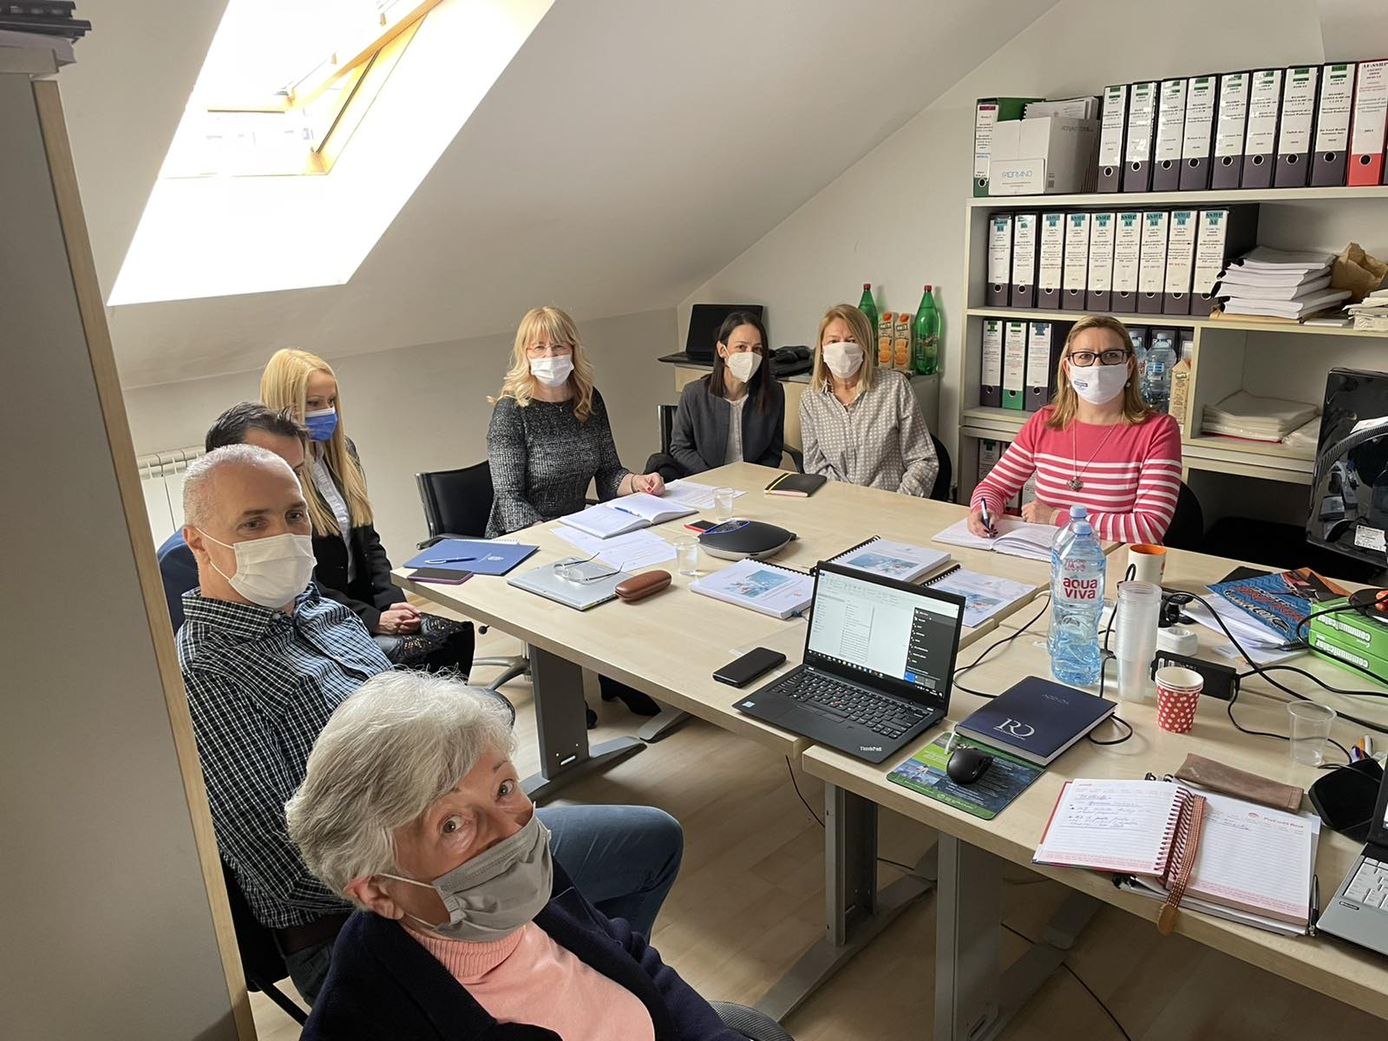
Picture 1: Public consultation in Belgrade, 24 February 2021
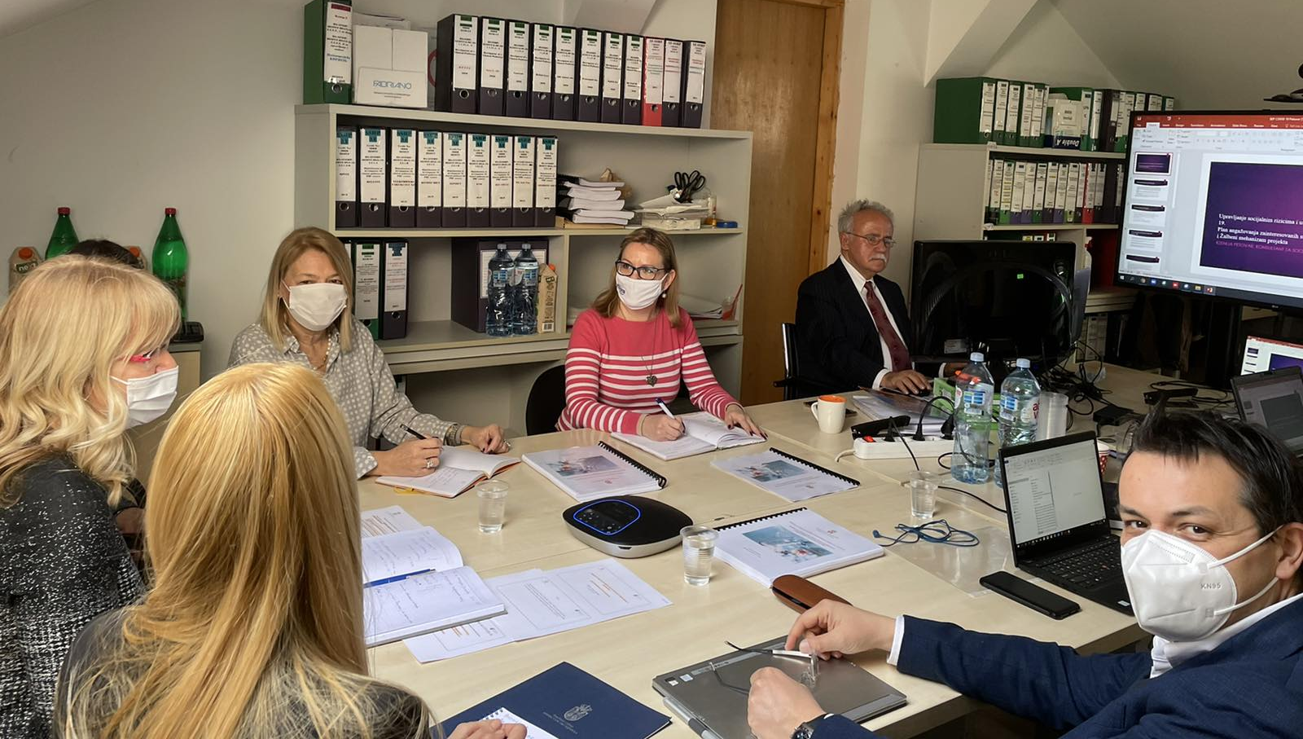
Picture 2: Public consultation in Belgrade, 24 February 2021
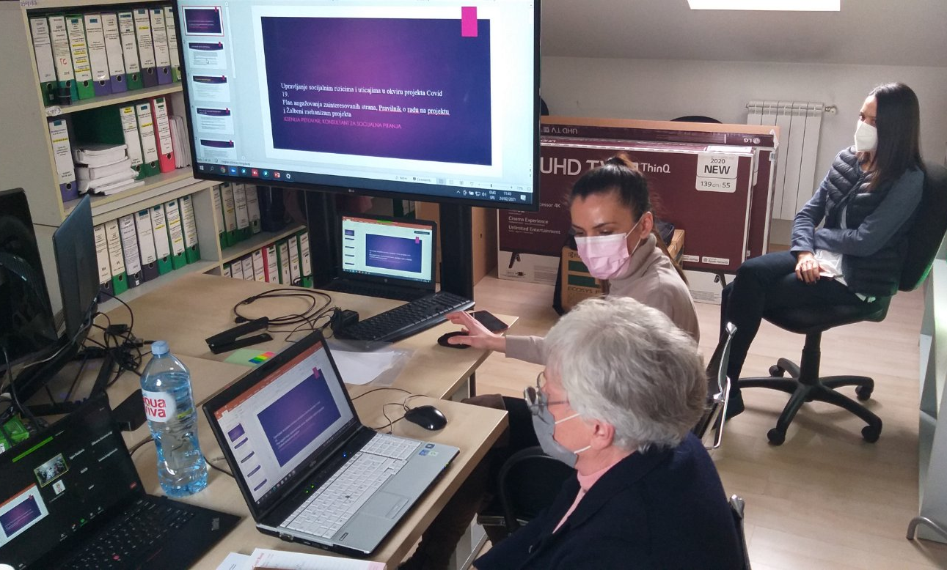
Picture 3: Public consultation in Belgrade, 24 February 2021

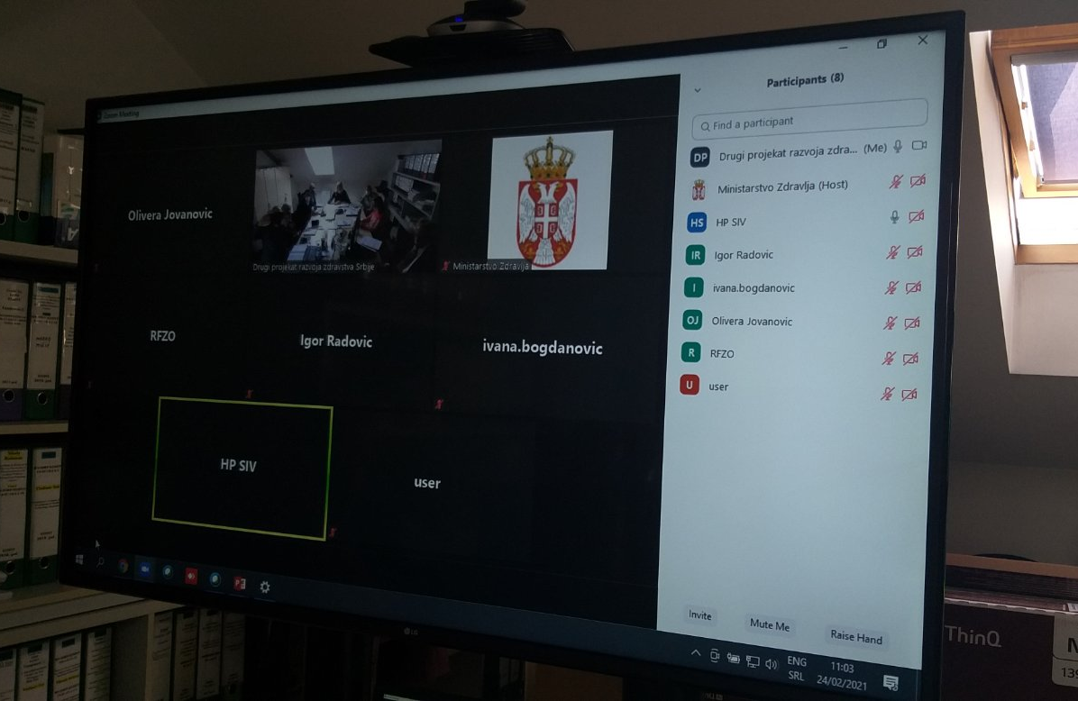
Picture 4: Online participants via Zoom platform, 24 February 2021

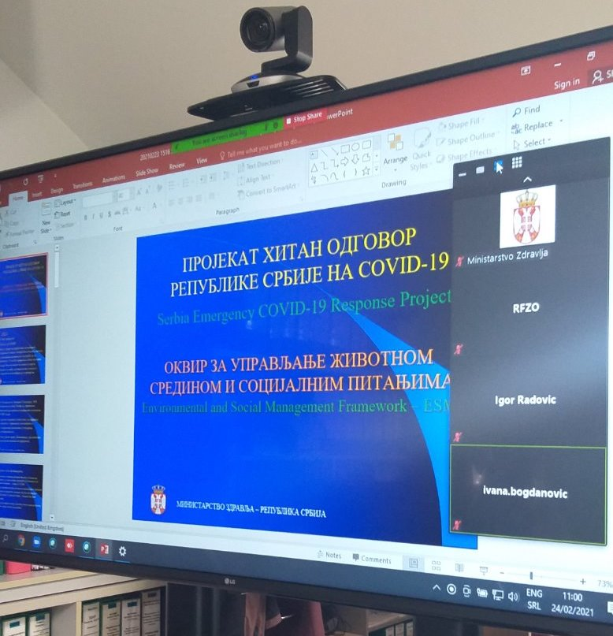
Picture 5: Online participants via Zoom platform, 24 February 2021

Special focus was given to the Project description, implementation arrangements, potential environmental and social impacts, grievance redress procedures, labor management, screening forms and development of environmental and social management plans during Project implementation.
The importance of labor management and most important provisions of WB Environmental and Social Standard ESS2 (Labor and Working Conditions) were also explained during presentation of ESMF document.
Before starting with questions of participants, institutional responsibilities and monitoring and reporting procedure on Project were presented and explained. However, the consultation had taken a participatory form and turned into a very interactive discussion with participation of all present stakeholders very early, before the moderator handed over the floor to the participants.

Comments, Questions and Answers during public presentation and consultations:

Q1: Ms. Ana Milijic, Coordinator of SECRP Subcomponent 1.2, informed the participants about the ongoing activities on the project, i.e. the Terms of Reference for soft activity - helping the population to overcome the consequences of long-term isolation during a pandemic caused by COVID-19 virus.
C1: Ms. Ksenija Petovar, the Social Specialist, further clarified the importance of inclusion of all citizens, especially vulnerable groups.
Opinions and remarks provided in written form:
Written opinions and remarks related to ESMF and SEP documents were not received during the 21 days intended for consultations with interested citizens and organizations.

LIST OF PARTICIPANTS - PRELIMINARY CONSULTATIONS WITH KEY STAKEHOLDERS, 24 FEB 2021

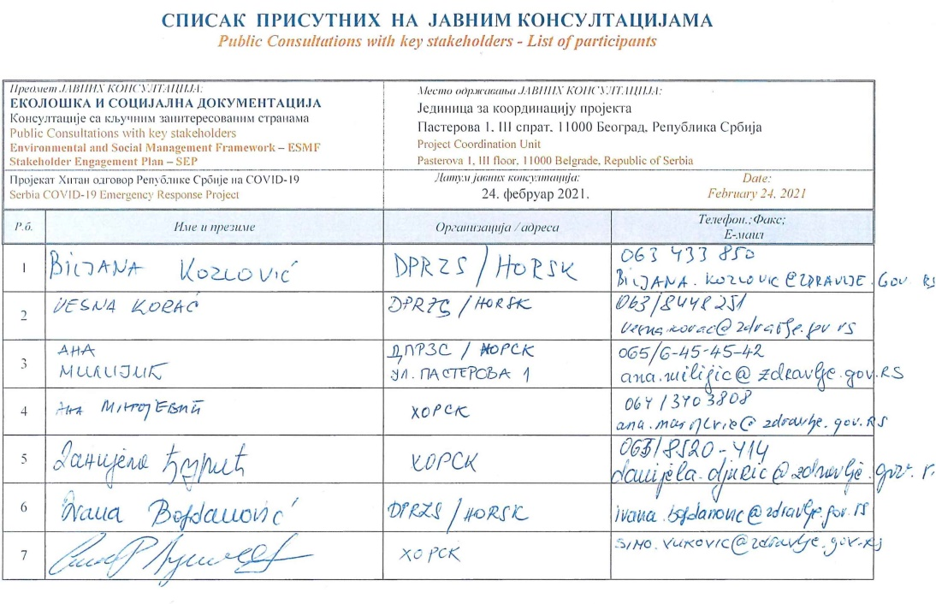

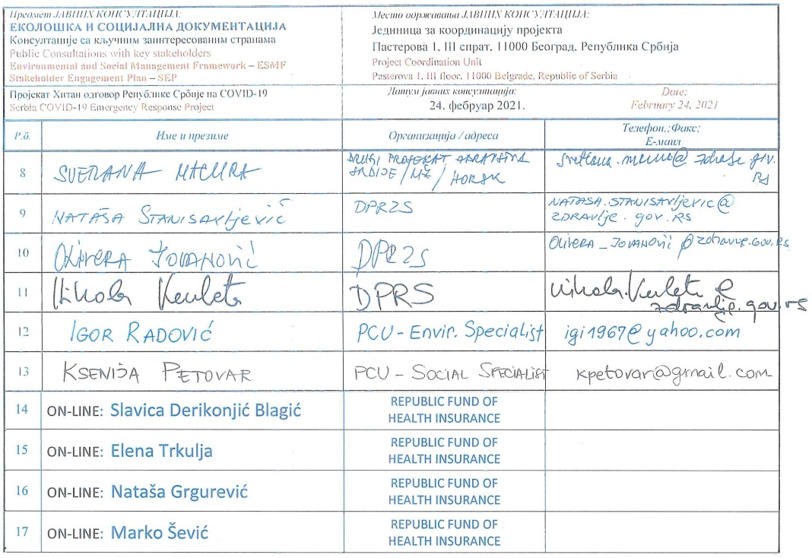

according to data published on www.covid19.rs and the Institute of Public Health of Serbia "Dr Milan Jovanovic Batut"
https://www.srbija.gov.rs/vest/en/165762/another-48-die-from-coronavirus-infection.php
Vulnerable status may stem from an individual’s or group’s race, national, ethnic or social origin, color, gender, language, religion, political or other opinion, property, age, culture, literacy, sickness, physical or mental disability, poverty or economic disadvantage, and dependence on unique natural resources.

